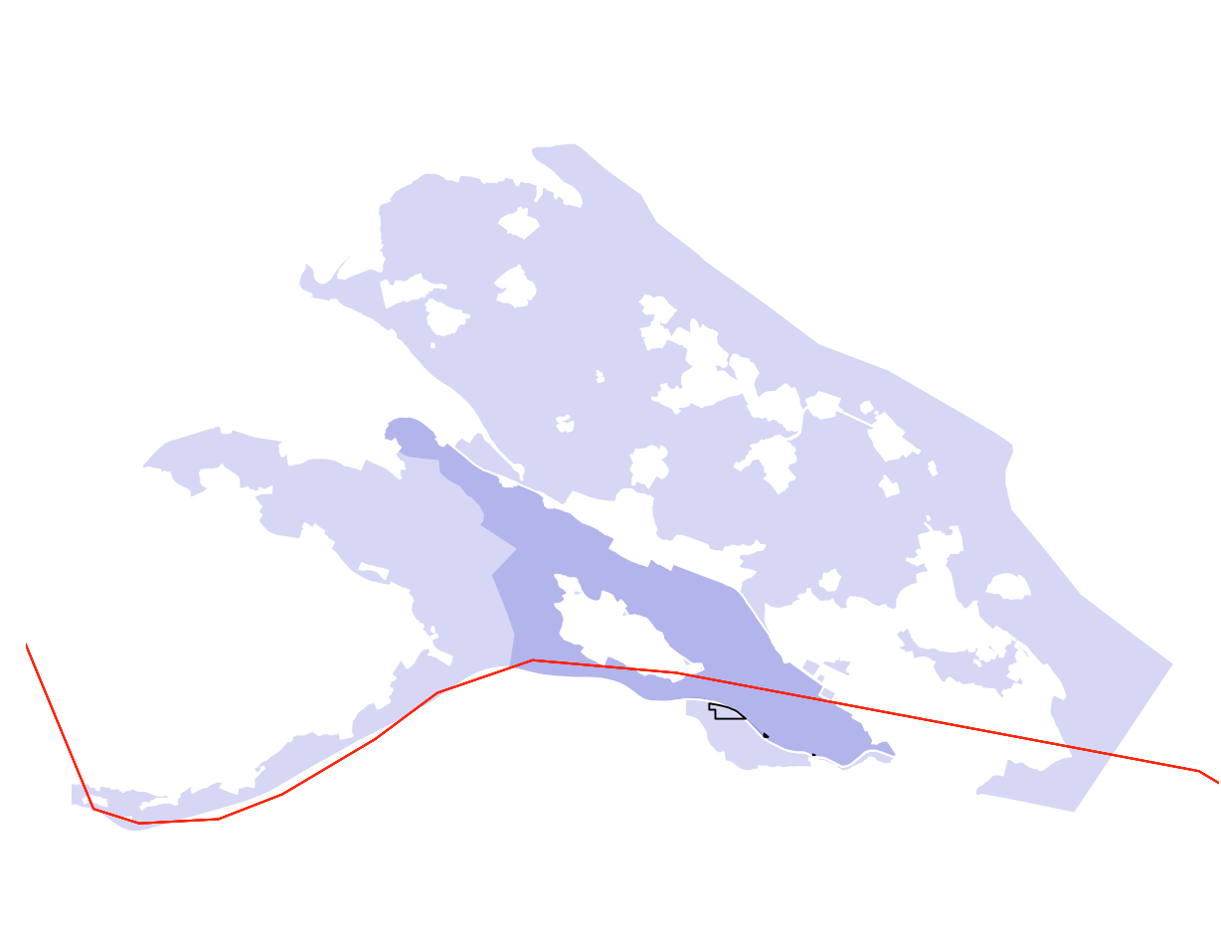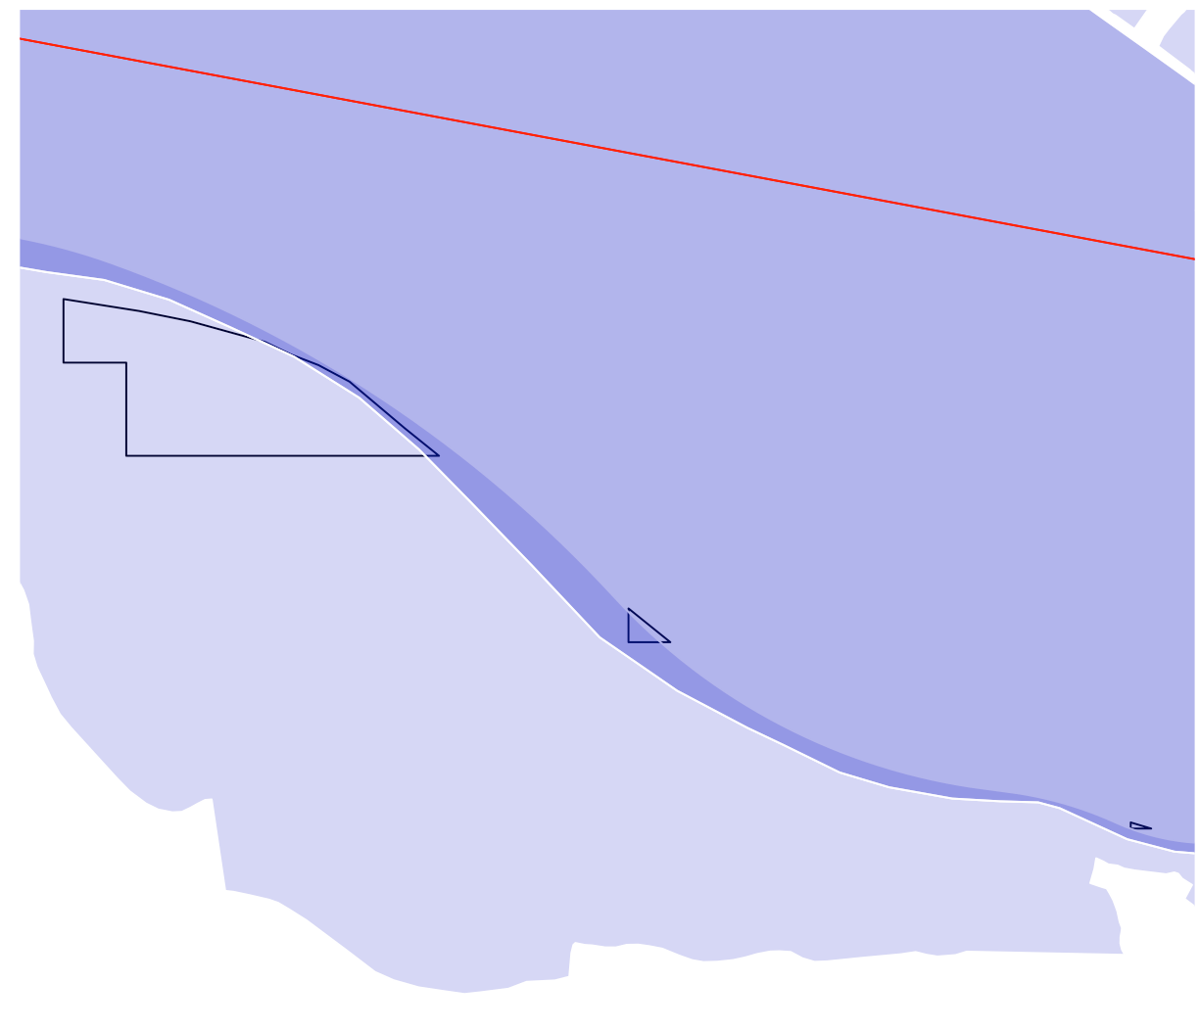

PA = Purple /// GMBA intersec KBA = Black outline /// country border = Red

Takes intersected GMBA/KBA file (so only portion of KBAs that fall within GMBA polygons)

Loops through each GMBA_V2_ID

Finds all PAs that this KBA_GMBA polygon overlaps with

Tracks all the countries that have that mountain range AND the specific country calculated (In this case DEU & CHE)

Calculates the coverage using same method as the original birdlife code